Project Development Phase-2
Dashboard Screenshot,
Story Screenshot Along
Tableau Public link

Date | 8 July 2026
Team ID | SWTID-2026-5839
Project Name | Visualizing Housing Market Trends: An Analysis of Sale Prices and Features using Tableau
Maximum Marks

Dashboard:
Comprehensive House Data Analysis
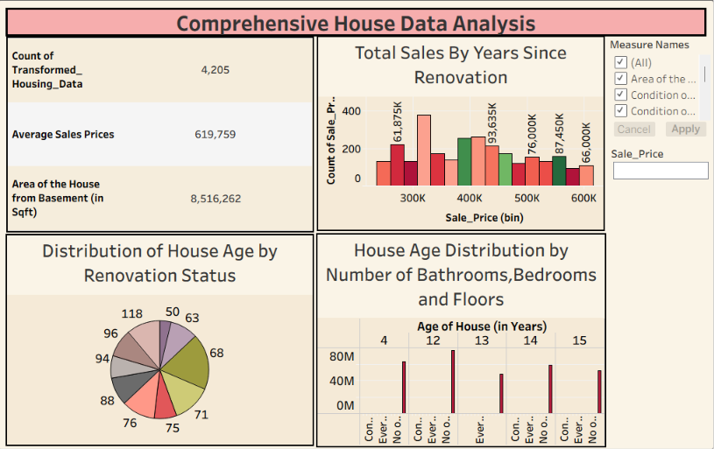
Dashboard:
Comprehensive House Data Analysis 2
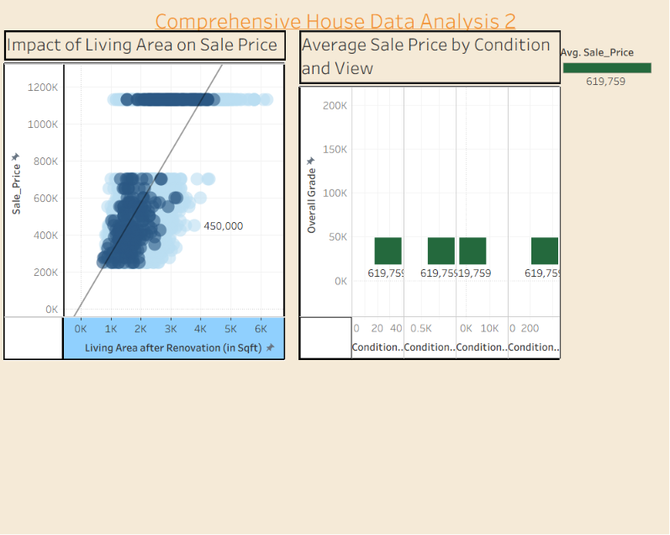

Story:
Visualizing Housing Market Trends: An Analysis of Sale Prices and Features using Tableau Story
- Total Sales By Years Since Renovation
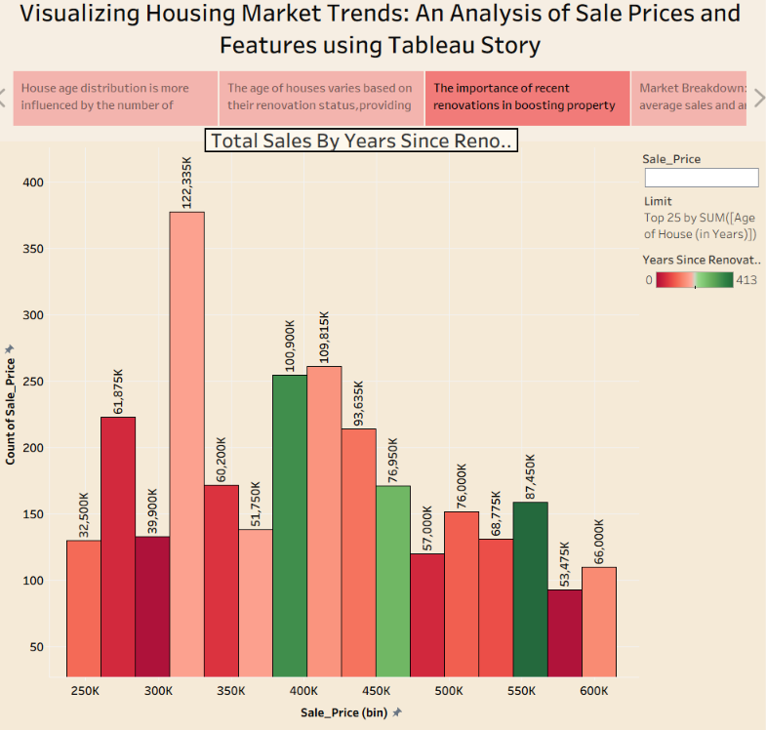

- Distribution of House Age by Renovation Status
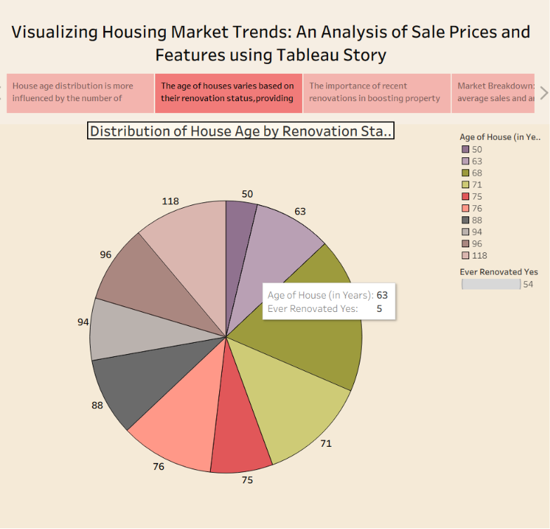

3.House Age Distribution by Number of Bathrooms, Bedrooms and Floors
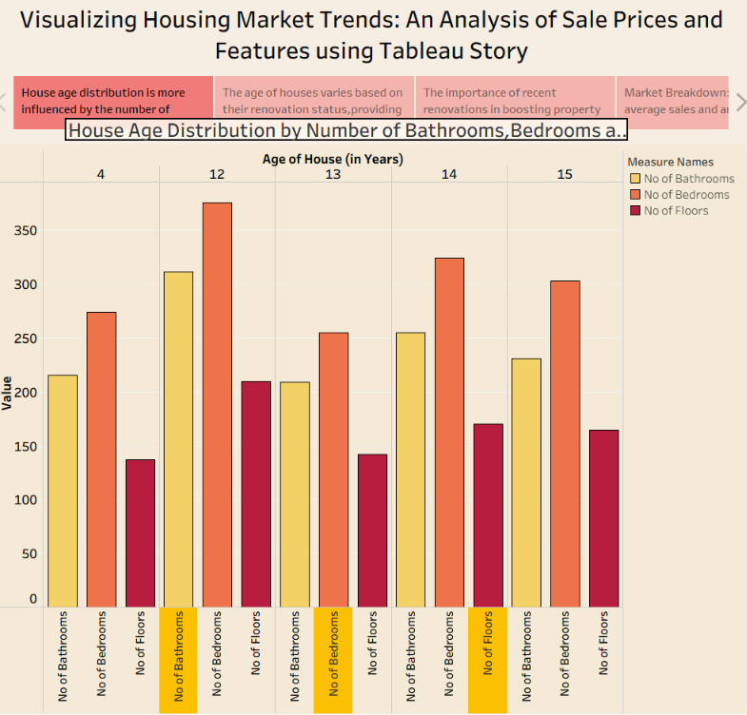

4.Viaualization
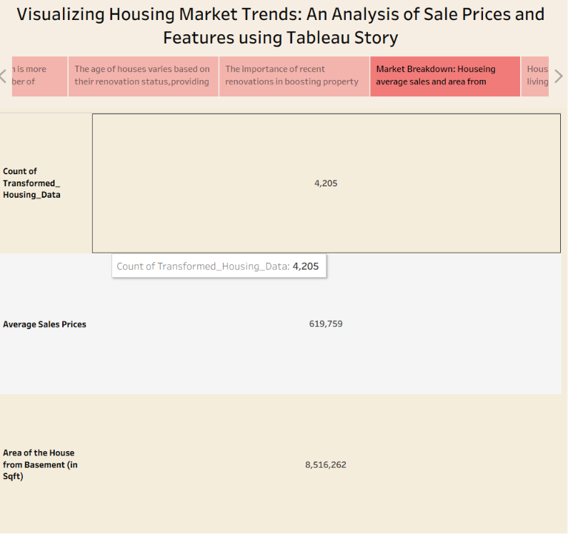

5. Impact of Living Area on Sale Price
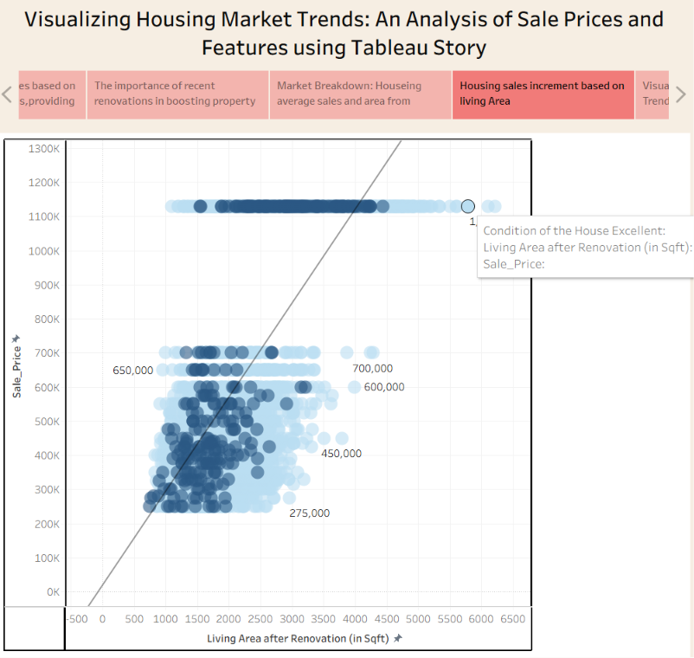

6. Average Sale Price by Condition and View
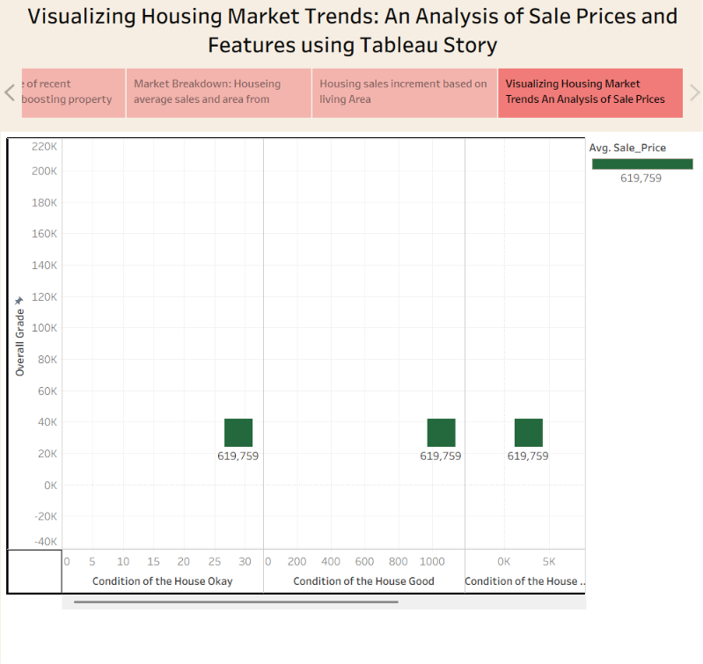

Here is Tableau Public Link--->
https://public.tableau.com/app/profile/rahul.kumawat1942/vizzes

Dataset Reference

Dataset Name: Transformed Housing Data 2

Dataset Source: National Load Despatch Centre (NLDC), Government of India (via Kaggle)

Dataset Link:

https://www.kaggle.com/datasets/rituparnaghosh18/transformed-housing-data-2

Dataset Description:

This house costing data is transformed for data modelling and is the updated version of my previous dataset 'Transformed Housing Data'. The updating is the creation of dummy variables of certain categorical features for modelling purpose. There is a total of 31 columns, out of which Sale Price can be supposedly taken as a dependent variable. The other variables are different features, locations and date, etc. regarding the houses. Several EDA or regression modelling can be performed in this data after a little polishing and treatment.

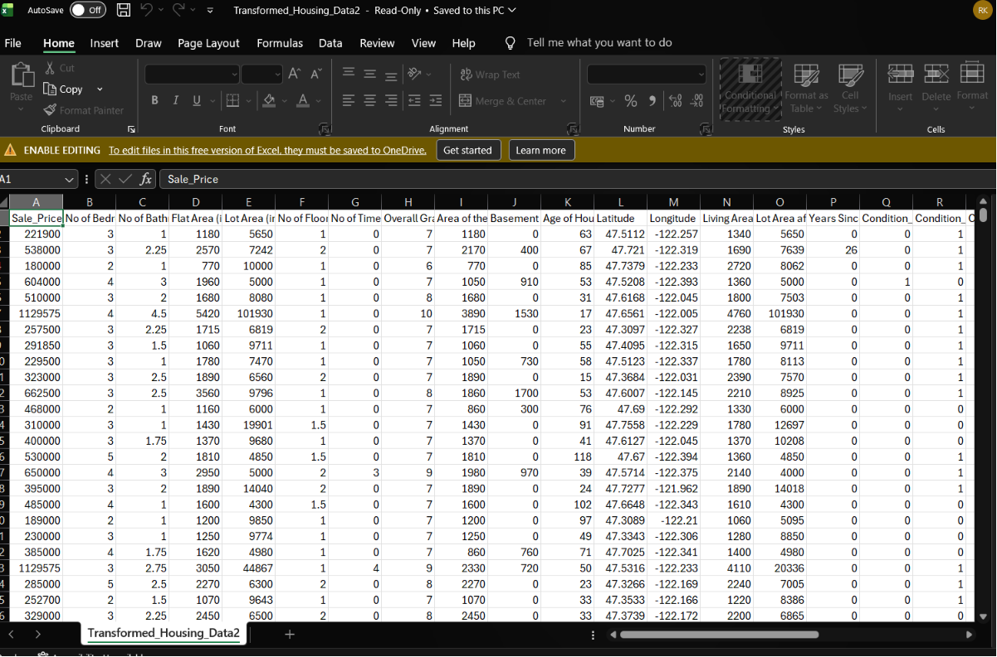
f.g-> Transformed Housing Data dataset schema

